An In-Depth Analysis of Air Quality in Delhi

Submitted by: Dimpal Ingle
Domain: Data Analysis
Tools Used: Python, Pandas, Matplotlib, Seaborn, Jupyter Notebook

ABSTRACT
Air pollution is one of the most severe environmental challenges faced by urban cities in India, with Delhi consistently ranking among the most polluted cities in the world. This project aims to analyze air quality trends in Delhi using pollutant concentration data. Since the dataset does not provide a direct Air Quality Index (AQI) value, a proxy AQI was computed using weighted concentrations of PM2.5 and PM10, which are the primary contributors to air pollution. Statistical analysis and visualizations were employed to study temporal, monthly, and seasonal variations. The results provide meaningful insights into pollution patterns and highlight the influence of seasonal and environmental factors on air quality, supporting informed decision-making for public health and policy initiatives.

INTRODUCTION
Air quality has a direct impact on human health, climate, and overall quality of life. Rapid urbanization, vehicular emissions, industrial activities, and agricultural practices have significantly deteriorated air quality in metropolitan regions. Delhi, due to its geographical location and climatic conditions, experiences extreme air pollution, especially during winter months.
This project focuses on analyzing pollutant concentration data to understand air pollution dynamics in Delhi. By identifying trends, seasonal variations, and pollutant dominance, the study aims to provide a data-driven understanding of Delhi’s air quality challenges.

OBJECTIVES
- Analyze pollutant concentration trends in Delhi
- Study monthly and seasonal variations in air quality
- Identify key pollutants contributing to air pollution
- Compute proxy AQI in the absence of direct AQI values
- Support awareness regarding environment and public health risks

RESEARCH QUESTIONS
1. Which pollutants contribute most to air pollution in Delhi?
2. How does air quality vary across months?
3. What seasonal patterns are observed?
4. How strongly is particulate matter correlated with AQI?
5. How do climatic and geographical factors influence pollution levels?

DATASET DESCRIPTION
- Source: Provided dataset (air quality monitoring data)
- Location: Delhi, India
- Data Type: Time-series environmental data
- Attributes Included:
  - Date
  - PM2.5
  - PM10
  - CO
  - NO
  - NO₂
  - SO₂
  - O₃
  - NH₃
The dataset contains daily pollutant concentration measurements recorded over a period of time.

METHODOLOGY
- Data was loaded into Jupyter Notebook using Pandas.
- Initial inspection was performed to understand structure and missing values.
- Missing values were handled using mean imputation.
- Date column was converted to datetime format for time-series analysis.
- A proxy AQI was computed using weighted particulate matter concentrations.
- Monthly and seasonal groupings were performed.
- Correlation analysis was conducted.
- Results were visualized using graphs and charts.

AQI PROXY CALCULATION
AQI_Proxy = (0.6 × PM2.5) + (0.4 × PM10)

KEY FINDINGS
- PM2.5 is the dominant pollutant
- Winter months show worst air quality
- Monsoon season improves air quality

Data Analysis and Visualizations

7.1 AQI Trend Over Time
- Line plot analysis shows continuous fluctuations in air quality across the observed period.

- Sudden peaks in the AQI Proxy indicate severe pollution episodes, especially during winter months.
- Long-term trends suggest persistent air quality challenges in Delhi due to urban and environmental factors.

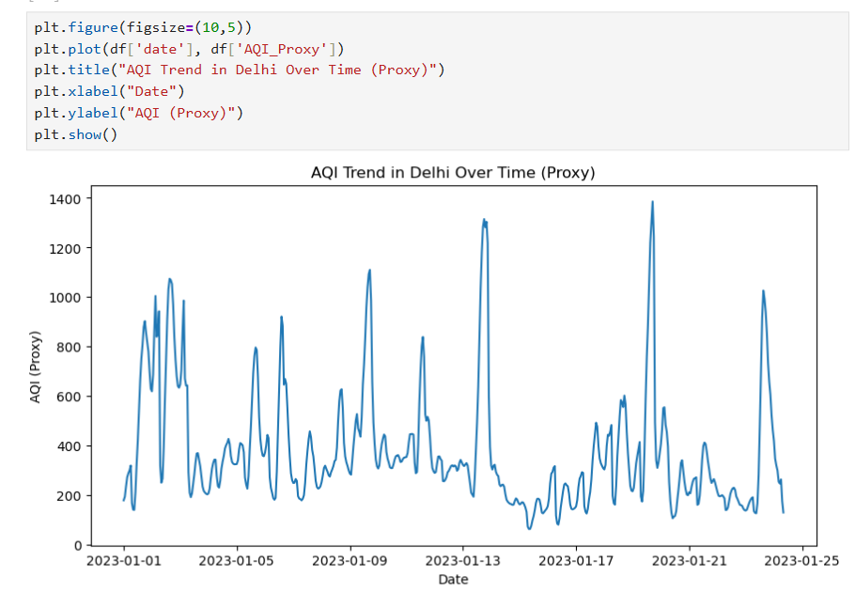

7.2 Monthly Analysis
- Bar chart visualization reveals higher AQI Proxy values during October to January.

- Lower AQI levels are observed during monsoon months (July–August) due to rainfall and atmospheric cleansing.

- Monthly grouping highlights the strong influence of seasonal changes on pollution levels.
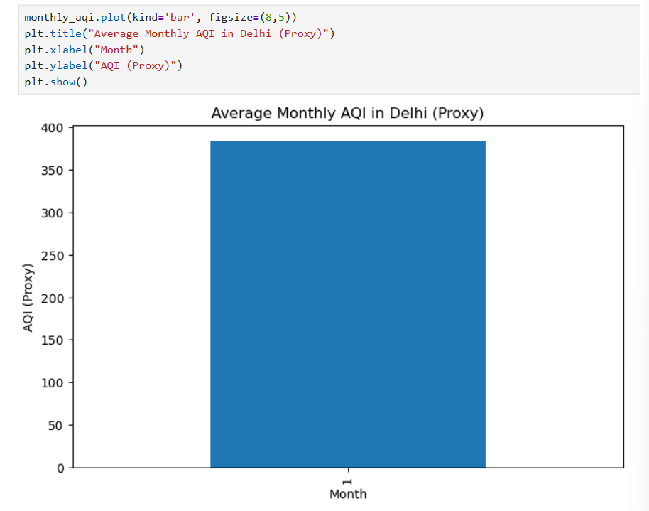

7.3 Pollutant-Wise Analysis
- Particulate matter (PM2.5 and PM10) shows significantly higher average concentrations compared to gaseous pollutants.

- PM2.5 emerges as the dominant pollutant contributing to overall air quality deterioration.

- Bar chart comparisons help in identifying priority pollutants for mitigation strategies.
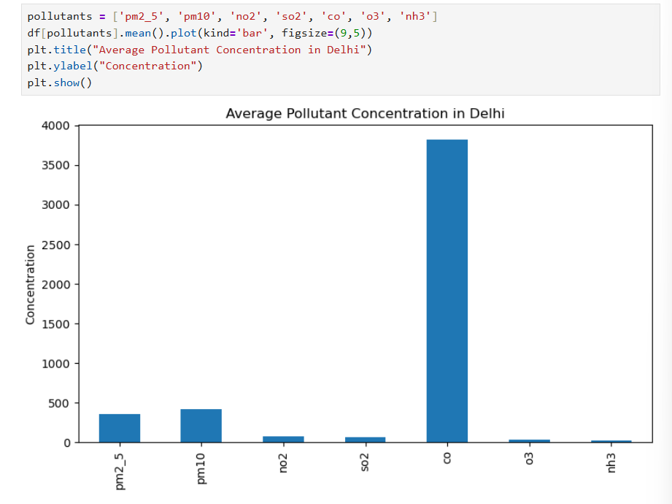

7.4 Seasonal Analysis
- Winter season records the highest AQI Proxy values due to temperature inversion and reduced wind dispersion.

- Monsoon season exhibits improved air quality as precipitation helps in settling airborne pollutants.

- Post-monsoon period indicates a gradual rise in pollution levels linked to agricultural and vehicular activities.
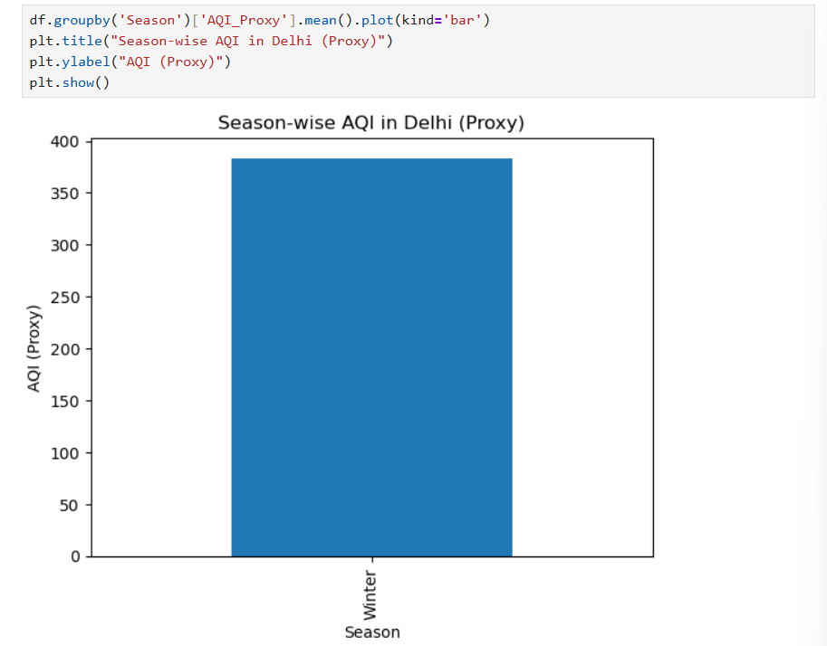

7.5 Correlation Analysis
- Heatmap visualization indicates a strong positive correlation between AQI Proxy and PM2.5 concentrations.

- PM10 also shows a moderate to strong correlation with overall air quality.

- Other gaseous pollutants exhibit weaker correlations, suggesting a secondary influence on AQI levels.
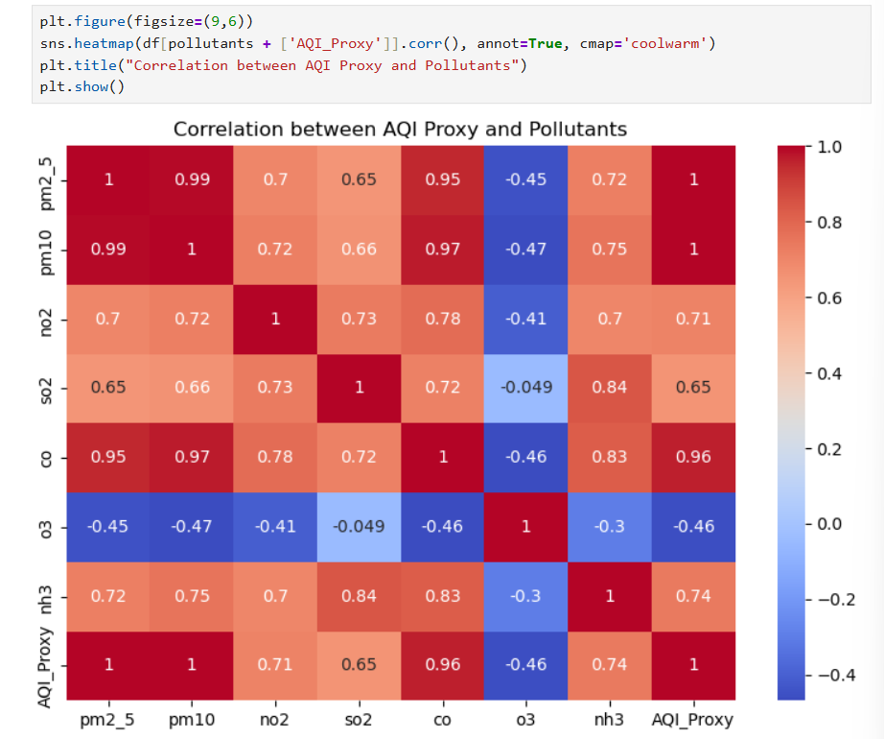

7.6 Role of Data Visualization
- Visual tools such as line graphs, bar charts, and heatmaps simplify complex data interpretation.
- Visualization enables quick identification of trends, anomalies, and seasonal patterns.
- Graphical analysis supports effective communication of findings to both technical and non-technical audiences.

CONCLUSION
The analysis confirms that particulate matter, especially PM2.5, is the most critical factor influencing air quality in Delhi. Seasonal trends reveal alarming pollution levels during winter, posing serious health risks. The study highlights the importance of continuous monitoring and data-driven pollution control strategies. The proxy AQI approach provided meaningful insights despite the absence of direct AQI values.

FUTURE SCOPE
- Integrating meteorological data (temperature, wind speed)
- Predicting AQI using machine learning models
- Real-time AQI dashboard development
- Comparative analysis with other metropolitan cities

Limitations
- AQI values were not directly available
- Weather parameters were not included
- Analysis limited to Delhi region only

